PAGE 1.1
Introduction to Python
Welcome to the Python course!
You're about to begin your journey with Python—one of the most popular and widely used programming languages in the world.
Why Learn Python?
Python is easy to understand, yet powerful enough to build many different types of projects.
It is used to create websites and applications, analyze data, automate tasks, and even develop solutions using AI.
Whether you're planning to build a career in technology or simply want to explore programming, Python is a great language to begin with.
For now, you don't need to write any code on this page.
Take a look at the editor on the right. You'll soon use it to write and run your own Python code.
And don't worry about making mistakes—you're here to learn. Follow along, try things out, and feel free to explore.
This course will take you through Python step by step with simple explanations and practical learning. No prior programming experience is required.
When you're ready, click Next Lesson, and let's run your very first Python program together.

PAGE 1.2
Run Your First Python Program
It's time to run your very first Python program!
Here is a simple Python program that displays Hello, World! on the screen.
print(" Hii , World! ")
Run Code >>

All you need to do is click the Run Code button.
You’ll see Hello, World! appear in the Output section.
Great job! 🎉 You’ve just run your first Python program.
Don't worry if the code doesn't make complete sense yet. In the next lesson, we'll break it down step by step and understand exactly how it works.
Ready to continue? Click Next Lesson and let's keep learning!

PAGE 1.3
Working of the Program
Let's take a closer look at the Python program you just ran.
In Python, we use the print() function to display something on the screen.
The print() function displays whatever we place inside its parentheses.
For example, this is the program you ran earlier:
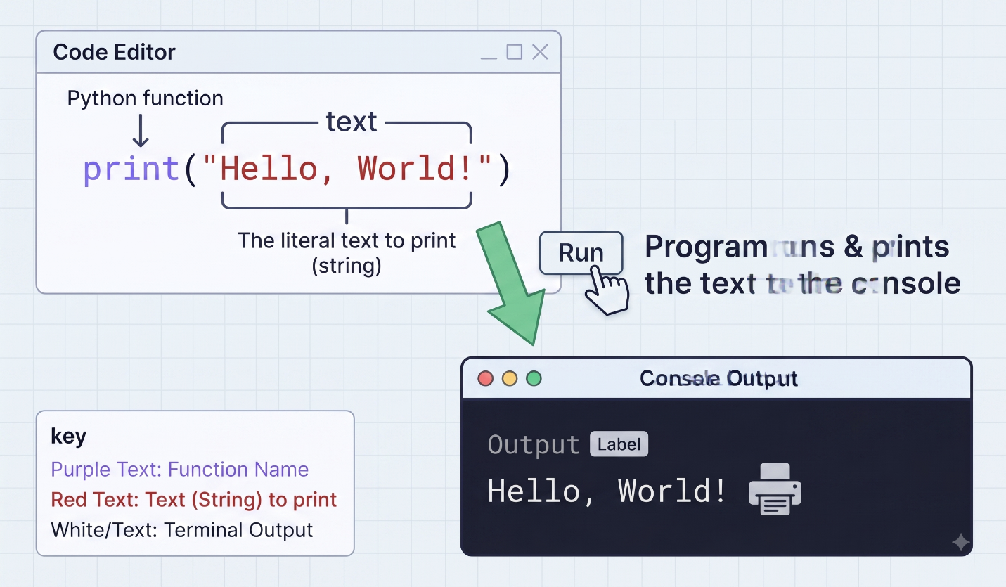Figure: Print Hello World
When you run this code, Python displays the text without the quotation marks.
The quotation marks " " tell Python that the content inside them is plain text and should be displayed exactly as written.
If you leave out the quotation marks, Python won't understand the text correctly and will show an error.
Next, you'll take a quick quiz to check what you've learned. After that, you'll get to write your very first Python code yourself.
Click Next Lesson to continue.

PAGE 1.4
Quiz: Which of the following is the correct way to display Welcome to Go Coder on the screen?
Tap an option below to answer:
A: print(Welcome to Go Coder)
B: print "Welcome to Go Coder"
C: print("Welcome to Go Coder")
D: Print("Welcome to Go Coder")

PAGE 1.5
Your First Python Greeting
Problem Description
Write a Python program that displays the message Welcome to Go Coder on the screen.
In the code editor, write your program using the print() function.
Remember:
- Use the print() function to show the message.
- Put the text inside quotation marks " " so Python recognizes it as text.
- Make sure the capitalization and spacing match exactly: Welcome to Go Coder.
When you finish, click the Run button to see the output.
Good luck!
Example
Expected Output

Welcome to Go Coder

SOLUTION
Here is the solution for the given problem:
print("Welcome to Go Coder")

Would you like EXPLAIN ?
Welcome to the world of coding, where every line matters! Here's how it works:
This line of code is a simple print statement that displays the text "welcome" on the screen. It's like saying hello to everyone who opens your program.
In programming, the print function outputs whatever you put inside the parentheses. It’s often the first step to ensuring everything is running smoothly.
So, think of this as your starting point in learning to communicate with computers.
Ready to explore what else you can express in code?

PAGE 1.6
Course Overview
Great job completing your first Python program!
You'll learn and write lots more code throughout this course. Here's what to expect:
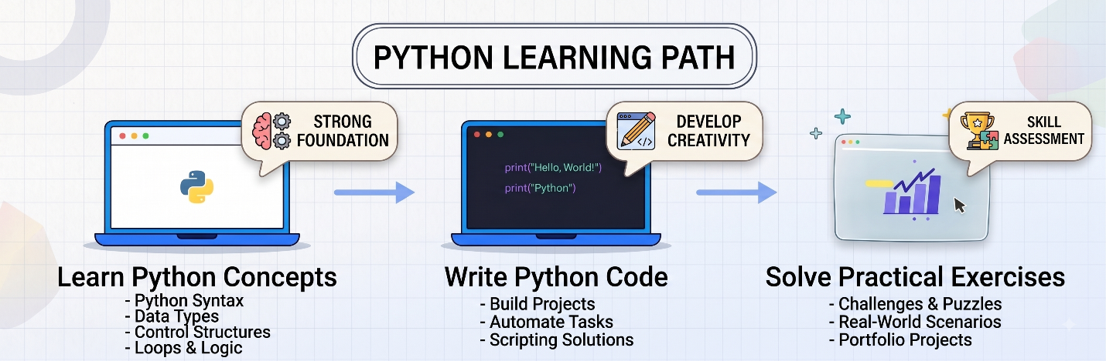
Figure: Course Flow
By the end, you'll write hundreds of programs and create projects, including the rock-paper-scissors game, and become ready to work on real-world projects.
Click the Next Lesson button to continue your learning journey!

PAGE 2.1
Introduction to Data Types
Hii! Do you remember this from the previous lesson?
print(" Welcome to Go Coder ")

Run Code >>

Anything written inside quotation marks (" ") is considered text. In programming, this type of text is known as a string.
In this lesson, you'll discover two of the most frequently used data types:
- Strings — used to store text, like the "welcome" example above
- Numbers — used for mathematical operations and calculations

Note: You don't have to be an expert at math. We'll only work with simple operations like addition, subtraction, and multiplication. So there's no need to worry—you can do this!

Next, let's learn more about strings.
Click Next Lesson to continue.

PAGE 2.2
Working with Strings
Now you know that any text placed inside quotation marks is called a string in Python. For example:
"This is a string."

You can also write strings using single quotation marks :
'This is another string.'

To display a string on the screen, place it inside the print() function:
print("This is a string.")
print('This is also a string.')

Run Code >>

Click the Run Code button to view the result.
You can use either single or double quotes. Just remember to use them consistently to keep your code clean and easy to read.
But what happens if you leave out the quotation marks?
We'll discover that in the next lesson.
Click Next Lesson to continue.

PAGE 2.3
Be Careful When Using Strings
If you write text without putting it inside quotation marks, Python will not treat it as a string. For example:
print(Hii dear)

Run Code >>

Output
ERROR! File "<string>", line 1
print( Hii dear )
^^^^^^^^^
SyntaxError: invalid syntax. Perhaps you forgot a comma?

If you run this code, Python will display an error.
Here's another example:
print( " Hii )

Run Code >>

Output
ERROR! File "<string>", line 1
print( " Hii )
^
SyntaxError: unterminated string literal (detected at line 1)

This error happens because the closing quotation mark is missing after "Hello.
These types of mistakes are very common when you're learning, so don't worry — with practice, you'll understand them quickly!
Ready for the next step? Next, you'll discover how small details — such as a capital letter or an extra space — can make a big difference.
Click Next Lesson to continue!

PAGE 2.4
Strings are Fixed Values
Do you remember the first Python program you created?
print("welcome to Go Coder")

Run Code >>

We asked you to write it exactly that way — and there is an important reason for it.
In Python, strings are case-sensitive. This means capital and small letters are considered different.
For example:
- "welcome to go coder" is not the same as "WELCOME TO GO CODER"
- "welcome to go coder" is not the same as "Welcome To Go coder"
- "welcome to go coder" is not the same as "WelCome To Go Coder"
Every letter must match exactly — including the spelling and capitalization.
Spaces are important as well.
Even one extra or missing space can make a string different.
- "welcome to go coder" is not the same as "welcome to go coder" (the spaces are different)
- "welcome to go coder" is not the same as " welcome to go coder" (there is a space at the beginning)
- "welcome to go coder" is not the same as "welcome to go coder " (there is a space at the end)
They may appear almost identical to us, but Python treats each one as a different value.
So, always check your spelling, capitalization, and spaces carefully.
Next, let's explore how numbers work in Python.

PAGE 2.5
Understanding Numbers
Python has two commonly used kinds of numbers:
1. Integers
Integers are whole numbers that do not have a decimal point. They may be positive, negative, or zero. Examples are 8, -15, 0, and 20.
2. Floating-Point Numbers
Floating-point numbers include a decimal point. They can also be positive, negative, or zero. Examples are 3.5, 7.25, 0.0, and -4.8.
You'll soon learn how to display these numbers, but first, let's take a short quiz about floating-point numbers.

PAGE 2.6
Quiz: Which of the following is not a floating-point number in Python?
Tap an option below to answer:
A : 0.06

B : 4.15

C : 6

D : -2.5

PAGE 2.7
Print Numbers
When you want to display a number in Python, you do not need to place it inside quotation marks. Numbers can be printed directly, unlike strings.
For example, to display the number 15 :
print(15)

Run Code >>

Output
15

Click the Run Code button, and 15 will appear on the Output screen.
You can display floating-point numbers, or numbers containing decimals, in exactly the same way:
print(240.44)

Run Code >>

Output
240.44

Click the Run Code button, and 240.44 will appear on the Output screen.
No quotation marks are needed — Python recognizes these values as numbers instead of text.
But what happens when you place quotation marks around numbers?
Let's discover that next!

PAGE 2.8
Understanding Numbers and Strings
Let's try printing 15 inside quotation marks:
print(" 15 ")

Run Code >>

Output
15

It looks the same as before, doesn't it? But there is an important difference:
Although both may appear identical to us, Python treats them differently.
- When you write print(15), Python recognizes 15 as a number.
- When you write print("15"), Python recognizes it as a string — or text.
This difference becomes important when you perform calculations.
Let's compare:
For example:
print( 6 + 3 )

Run Code >>

Output
9

Now try this:
print( "6" + "3" )

Run Code >>

Output
63

When you use numbers without quotation marks, Python adds them mathematically.
However, when numbers are inside quotation marks, Python treats them as text and combines them together.
Note: Don't worry if the + symbol is unfamiliar right now — you'll learn more about it and other operators later in the course in the Arithmetic Operators lesson. For now, this example simply shows the difference between numbers and strings.

Next, you'll answer a quick quiz and then complete a short practice exercise to strengthen what you've learned.

PAGE 2.9
Quiz: Which of the following is not a string in Python?
Tap an option below to answer:
A : '1234'

B : " Hey, World! "

C : "55"

D : Python

PAGE 2.10
Write a program to display the number 78.9.
Hints:
- Use the print() function to display the number.
- Place 78.9 inside the print() function.
- Do not use quotation marks because you are printing a number, not text.
If you need help, you can check the Solution tab.
Example
Expected Output
78.9

Solution
Would you like to see the complete solution? Click below.
View full solution
sensAl
Here is the solution for the given problem description.
print(78.9)

Want to understand how the solution code works? Let me explain.
Explain this code
print(78.9)
Looks perfect, right? Here's what happens:
When you use print(78.9), Python displays the number 78.9 on the screen. Simple!
The print() function tells Python to show whatever is placed inside the parentheses. Since 78.9 is written without quotation marks, Python recognizes it as a number.
Try changing the number and running the code again. You'll see the output change too!
Ready to continue exploring Python and discover more things you can do with code?

PAGE 2.11
Print Numbers and Strings
You've already used the print() function several times — great work!
Let's look at another example to help you become even more familiar with print():
print(10)
print("How are you?")

Run Code >>

Output
10
How are you?

Every time you use print(), Python automatically displays the next output on a new line.
That's why 10 appears on the first line, while "How are you?" appears on the second line.
Note: You'll learn more ways to use print() later in the Output section. For now, there's no need to worry — this course will guide you step by step without making things confusing. Keep learning — you're doing a great job!

Next, you'll complete a quick practice exercise using the same concept — printing both a string and a number.

PAGE 2.12
Problem
Write a program to print a string and a number.
- Print Go Coder on the first line.
- Print 100 on the second line.
Hints:
- Use the print() function two times — one for each output.
- Put quotation marks around Go Coder because it is text.
- Do not use quotation marks around 100 because it is a number.
- Each print() automatically displays its output on a new line.
- Check the spelling, capitalization, and spacing carefully.
If you need help, you can check the Solution tab.
Example
Expected Output
Go Coder
10

SOLUTION
Would you like to view the full solution? Click below to see it.
View full solution
sensAI
Here is the solution for the given problem description.
print("Go Coder")
print(100)

Want to understand how the solution code works? Let me explain.
Let's see how this code works!
The first print() function displays the text "Go Coder" on the screen. Because it is text, it is written inside quotation marks.
The second print() function displays the number 100. Since it is a number, quotation marks are not needed.
Each print() creates its own line, so the text appears first and the number appears below it.
Together, these two lines show how Python can print both text and numbers.
What will you try printing next?

PAGE 3.1
Introduction to Comments
As you begin writing more programs, you may want to include short notes in your code—not for Python, but for yourself or other people who read your code later.
Imagine you have this line:
print(36.0)

Run Code >>

This code simply displays the number 36.0.
Now, suppose you want to describe what this number represents. It could be a temperature or the answer to a calculation. You might try writing:
print(36.0) this shows the temperature

Run Code >>

However, Python does not understand this additional text and will produce an error.
So, how can you add useful notes to your code without causing any problems?
This is where comments are useful. Comments allow you to write notes directly in your code, and Python ignores them when the program runs.
You don't need to learn the syntax for writing comments just yet.
Click Next Lesson to discover how to write comments correctly in Python.

PAGE 3.2
Python Comments
In Python, the # symbol is used to add comments to your code.
In the previous lesson, we saw that writing something like this:

print(36.0) this is the temperature

Run Code >>

Will cause an error. This happens because Python tries to understand everything written on that line, including the extra text.
Sometimes, however, you may want to add a short note explaining what your code does. You can do this by using a comment.
Simply place a # before your note, like this:

print(36.0) # this is the temperature

Run Code >>

Now, Python runs print(36.0) and ignores everything written after the #.
Python also ignores any complete line that begins with #. Comments are not executed and do not appear in the output.
Next, you'll explore more examples of Python comments.
Click Next Lesson to continue.

PAGE 3.3
Understanding Python Comments
Let's look at one more example:
# Display the first number
print(16)
print(14)
# Display another number
# Display the third number
print(86.3)

Run Code >>

This code contains three comments:
# Display the first number
# Display another number
# Display the third number

Python ignores all of these comments when it runs the program. Only the print() statements are executed.
So, the code works the same as:
print(16)
print(14)
print(86.3)
Run Code >>

The output will be:
16
14
86.3

Comments help describe and organize your code, but they do not change what the program does.

Note: You will see comments throughout this course to help explain different code examples.

Next, you'll test your understanding with two short quizzes about identifying comments and learning how they affect a program.
Click Next Lesson to continue.

PAGE 3.4
Quiz: Identify the comment from the following lines of Python code:
# print Hello World
print("Hey Buddy")

Tap an option below to answer:
A : print("Hey Buddy")

B : #

C : # print Hey Buddy

D : # print Hey Buddy
print("Hey Buddy")

PAGE 3.5
Quiz: What is the output of the following Python code?
# print("Hey Buddy")
print(10)

Tap an option below to answer:
A : 10

B : Hey Buddy

C : Hey Buddy
10

D : # print("Hey Buddy")

PAGE 4.1
Introduction to Variables
In the earlier lessons, you learned about strings and numbers and how to display them using Python.
As your programs become more advanced, you will often need to save data and use it later instead of simply printing it. This is where variables become useful.
A variable is like a container that stores information.
In this lesson, you'll learn how to:
- Create variables
- Print the values stored in variables
- Update the values of variables
Let's begin by learning how to create variables.

PAGE 4.2
Create Variables
You can create a variable by assigning a value to it. For example:
greeting = "Happy Holidays"

Here,
- greeting is a variable.
- greeting stores the string value "Happy Holidays".
- The = symbol is used to assign a value to a variable.

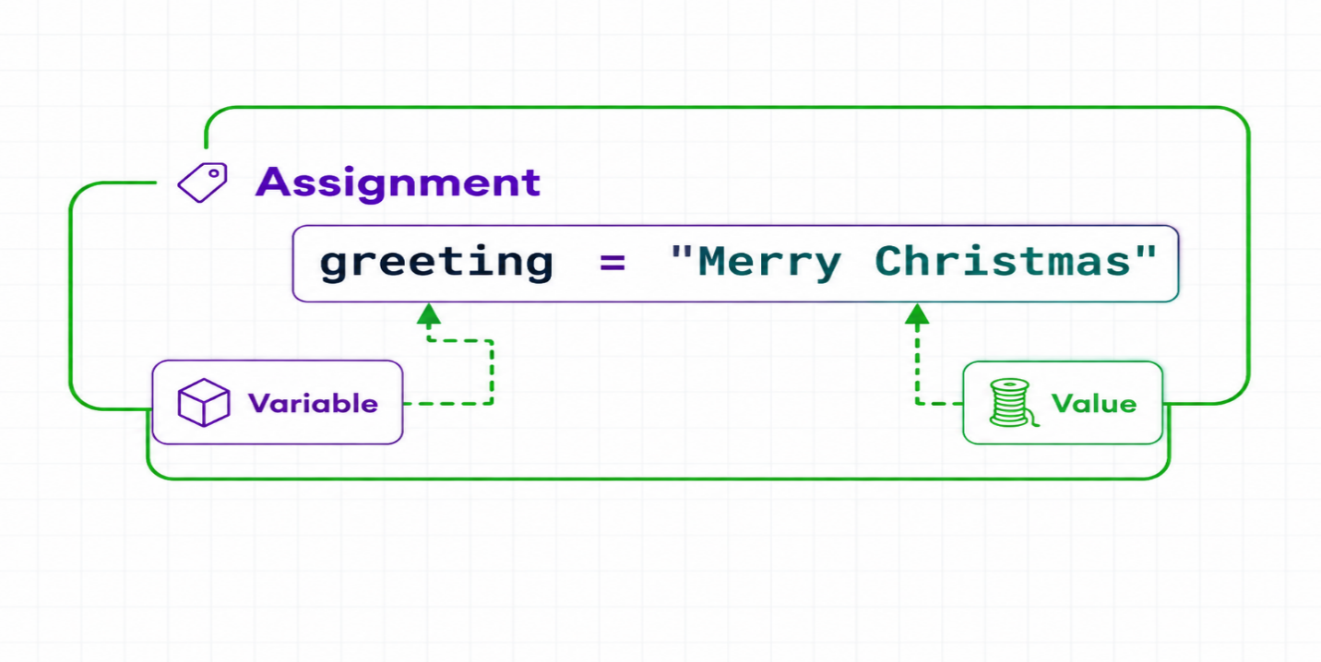
Figure: Assign Value to Variable
Next, let's see if you can identify variables correctly.

PAGE 4.3
Quiz: What is the variable in the following Python code?
ali = "name"

Tap an option below to answer:
A : ali

B : "name"

C : name

D : =

PAGE 4.4
Printing Variables
Just like numbers and strings, you can use the print() function to display the value stored in a variable.
# Create a variable
greeting = "Happy Holidays"
# Display the variable
print(greeting)

Output
Happy Holidays

Here:
- greeting = "Happy Holidays" — Creates a variable called greeting and assigns it the string "Happy Holidays".
- print(greeting) — Displays the value stored in the greeting variable.

Remember: The lines beginning with # are comments. Python ignores them when running the program.

You might be wondering why print(greeting) displays Happy Holidays instead of the word greeting.
The next example will make this clear.

PAGE 4.5
Printing Variables
Let's explore another example of how variables can be printed.
greeting = "Happy Holidays"
print("greeting") # Output: greeting
print(greeting) # Output: Happy Holidays
Run Code >>

Output
greeting
Happy Holidays

Let's analyze each print() separately.
print("greeting")
Here, "greeting" is written inside quotation marks, so Python treats it as a string. Therefore, it displays the text greeting exactly as written.
print(greeting)
Here, greeting is not inside quotation marks, so Python recognizes it as a variable.
As a result, Python displays the value stored inside the greeting variable, which is Happy Holidays.

PAGE 4.6
A Common Mistake
Consider the following program:
print(age)

Run Code >>

Here, age is not placed inside quotation marks, so Python treats it as a variable.
However, the age variable has not been created or assigned a value yet. Because Python does not know what age refers to, the program produces an error.
To solve this problem, define the age variable before using it. For example:

PAGE 4.7
Quiz: What is the output of the following Python code?
name = "Ali"
print(name)
print("Michael")

Tap an option below to answer:
A : Michael

B : Ali
Micheal

C : name
Micheal

D : Micheal
Ali

PAGE 4.8
Quiz: What is the result of the following Python code?
name = "Ali"
print(age)

Tap an option below to answer:
A : name

B : Ali

C : age

D : The code results in an error.

PAGE 4.9
Print Variables
Write a program to display the value stored in a variable.
- Create a variable named score and assign 85.5 to it.
- Print the variable.
Example
Expected Output
85.5

SOLUTION
Would you like to view the full solution? Click below to see it.
View full solution
sensAI
Here is the solution for the given problem description.
score = 85.5
print(score)

Want to understand how the solution code works? Let me explain.
Explain this code
Let's see how it works:
In this code, we create a variable called score and assign the value 85.5 to it. Think of the variable as a container that stores the number.
Next, print(score) displays the value stored in the score variable on the screen.
This simple example shows how variables can store information and how print() can be used to display that information.
Ready to continue learning more about variables in Python?

PAGE 4.10
Change Values Stored in Variables
A variable's value can be updated while a program is running. That's why it is called a variable. For example:
age = 35
print(age)
age = 75
print(age)
Run Code >>

Output
25
100

Here,
- At first, the variable age stores the value 35, so the first print(age) displays 35.
- Later, the value of age is changed to 75, so the second print(age) displays 75.
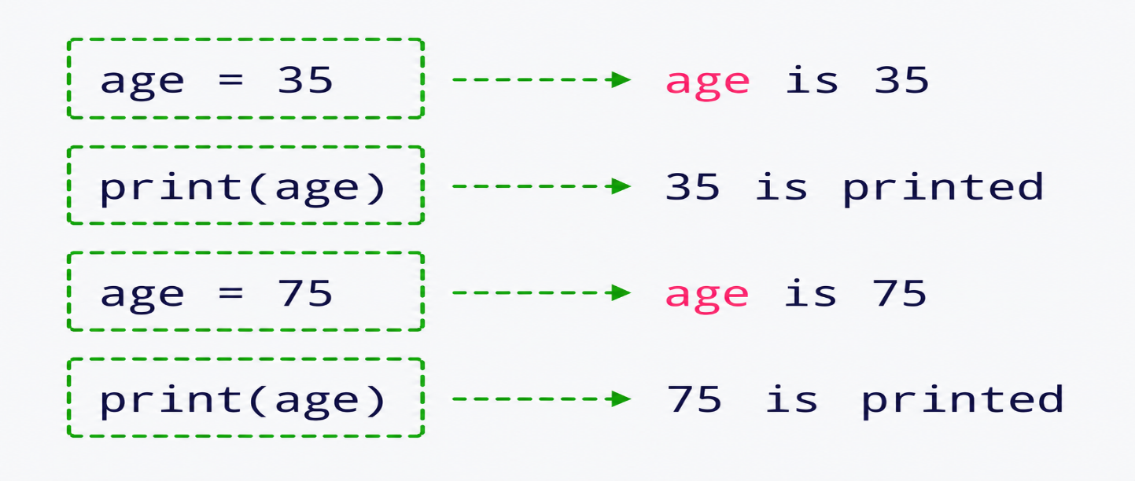
Figure: Change Values Stored in Variable
PAGE 4.12
PROBLEM
Change Values Stored in a Variable
Write a program to update the value stored in a variable.
- Create a variable named item and assign the value 10 to it.
- Print item.
- Change the value of item to "Book".
- Print item again.
Example
Expected Output
10
Book

SOLUTION
Would you like to view the full solution? Click below to see it.
View full solution
sensAI
Here is the solution for the given problem description.
# Assign 25 to the variable var
var = 25
# Print var
print(var)
# Assign "John" to the variable var
var = "John"
# Print var again
print(var)

Want to understand how the solution code works? Let me explain.
Explain this code
Let's see how the code works:
First, the variable item is created and assigned the number 10. When print(item) runs, Python displays 10.
Next, the value stored in item is changed from 10 to "Book". The variable now stores text instead of a number.
Finally, print(item) displays the new value:
Book
This example shows that the value stored in a variable can be changed at any time in a Python program.

PAGE 4.13
Quiz: What's the output of this Python code?
var = 60
var = "Ali"
var = 13.5
print(var)

Tap an option below to answer:
A : 13.5

B : 60
Ali
13.5

C : Ali

D : None of the above

PAGE 4.14
Assign Value of One Variable to Another
You can also assign the value of one variable to another.
color1 = "green"
print(color1) # Output: blue
color2 = "pink"
# Assign the value stored in color2 to color1
color1 = color2
print(color1) # Output: pink
print(color2) # Output: pink
Run Code >>

Output
green
pink
pink

Here's how the above program works.
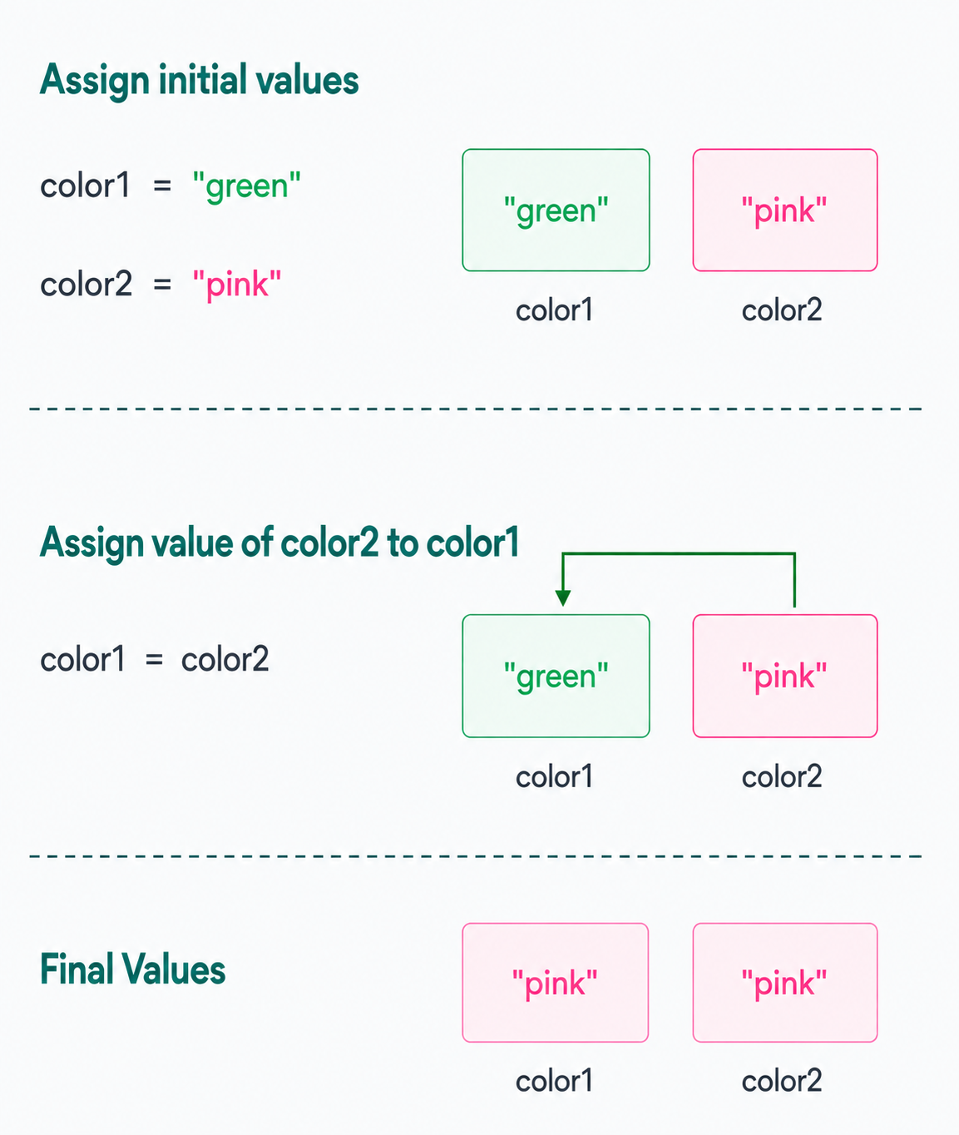
Figure: Assign Value of color2 to color1

Note: color1 = color2 assigns the value of the variable color2 to color1. However, this does not affect the value of color2; it remains unchanged.

PAGE 4.16
Assign Value of One Variable to Another
Consider the example below:
# Create a variable
city1 = "Paris"
# Assign city2 to city1
city1 = city2
print(city1)
Run Code >>

Output
NameError: name 'city2' is not defined. Did you mean: 'city1'?

In the program, the line city1 = city2 tries to assign the value of city2 to city1.
However, since city2 is not defined, the code produces an error.

PAGE 4.17
Quiz: What's the output of the following code?
color1 = "red"
colour2 = "blue"
colour1 = colour2
print(colour1)

Tap an option below to answer:
A : red

B : blue

C : redblue

D : The code results in an error.

PAGE 4.18
Quiz: What's the output of the following code?
country1 = "India"
uae = "country3"
country2 = country1
print(country3)

Note: This is a tricky one! Analyze the code carefully.
Tap an option below to answer:
A : Error because country3 is not defined.

B : Error because country2 is not defined.

C : Error because country1 is not defined.

D : India

PAGE 4.19
PROGRAM
Assign One Variable to Another
Write a program to assign the value of one variable to another.
- Create a variable named first_name and assign it the value "Ali".
- Print the value of first_name.
- Create another variable named name and assign it the value "Sara".
- Assign the name variable to the first_name variable.
- Print the first_name variable again.
Example
Expected Output

Ali
Sara

SOLUTION
Would you like to view the full solution? Click below to see it.
View full solution
sensAI
Here is the solution for the given problem description.
# Create the first_name variable
first_name = "Ali"

# Print first_name
print(first_name)

# Create the name variable
name = "Sara"

# Assign name to first_name
first_name = name
# Print first_name again
print(first_name)

Want to understand how the solution code works? Let me explain.
Explain this code
First, first_name is assigned the value "Ali", and Python prints it.
Next, the variable name is assigned the value "Sara".
Then, first_name = name copies the value stored in name into first_name. The value of first_name is now "Sara".
Finally, print(first_name) displays the updated value.

PAGE 4.20
Legal Variables Names
Python has some rules that you need to follow when naming variables. Let's take a look at them.
A variable name can contain only:
- letters
- numbers
- underscores
Spaces and other special symbols cannot be used in a variable name. If your variable name contains two words, you can separate them using an underscore _ or write them using camelCase.
For example, first name and first-name are invalid variable names. However, first_name and firstName are valid.
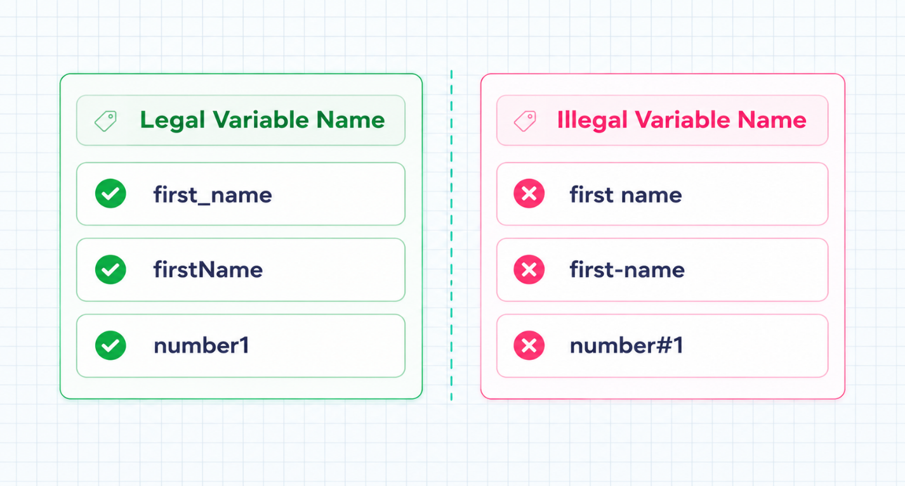
Figure: Legal and Illegal Variable Names

Keep in mind that just because a variable name is valid does not mean it is a good choice. For example, abc is a valid name, but it does not clearly describe what the variable stores.
Refer to this article to learn how and why you should assign clear and meaningful names to variables.

PAGE 4.21
Review: Variable Basics
Create Variables
We create variables by assigning values to them.
age = 35
print(age) # Output: 35
Run Code >>

Change Values of Variables
It's possible to change values stored in variables.
score = 85.5
print(score) # Output: 85.5

# Change the value stored in the variable
score = 125.5
print(score) # Output: 125.5
Run Code >>

Assign One Variable to Another
We can also assign the value of one variable to another.
color1 = "green"
color2 = "pink"
# Assign the value stored in color2 to color1
color1 = color2
print(color1) # Output: pink

Run Code >>

Don't Confuse Strings and Variables
Strings are always wrapped inside quotation marks, but variable names are not.
city = "paris"
# Print the value stored in the city variable
print(city) # Output: paris
# Print the "city" string
print("city") # Output: city
Run Code >>

PAGE 5.1
Introduction to Output
We have already used print() to display one value or variable at a time. Here's a quick review:
# Print a number
print(42) # Output: 42

# Print a string
print("Python") # Output: Python

# Create a variable
country = "Qatar"

# Print the country variable
print(country) # Output: Qatar
Run Code >>

Next, you'll learn how to display multiple values and variables using print(). You'll also explore f-strings, which provide an easy way to combine and format different pieces of data in your output.

PAGE 5.2
Print Multiple Values
You can display more than one piece of data in a single print() statement by separating the values with commas. For example:
# Display three numbers
print(25, -8, 42)
# Display two strings
print("Hey.", "Are you enjoying the course?")
# Display numbers and strings
print("Score:", 9.5)
Run Code >>

Output
25 -8 42
Hii. Are you enjoying the course?
Score: 9.5

Here, commas separate the values but do not appear in the output.
Also, adding spaces before or after a comma does not change the result. By default, print() places a single space between each value.

PAGE 5.3
Print Strings and Variables
You can also display values and variables using a single print() function. For example:
name = "Ali"
print("Name:", name)
Run Code >>

Output
name = "Ali"

Here, the print() function displays the string "Name:" as it is, and displays the value stored in the variable name .
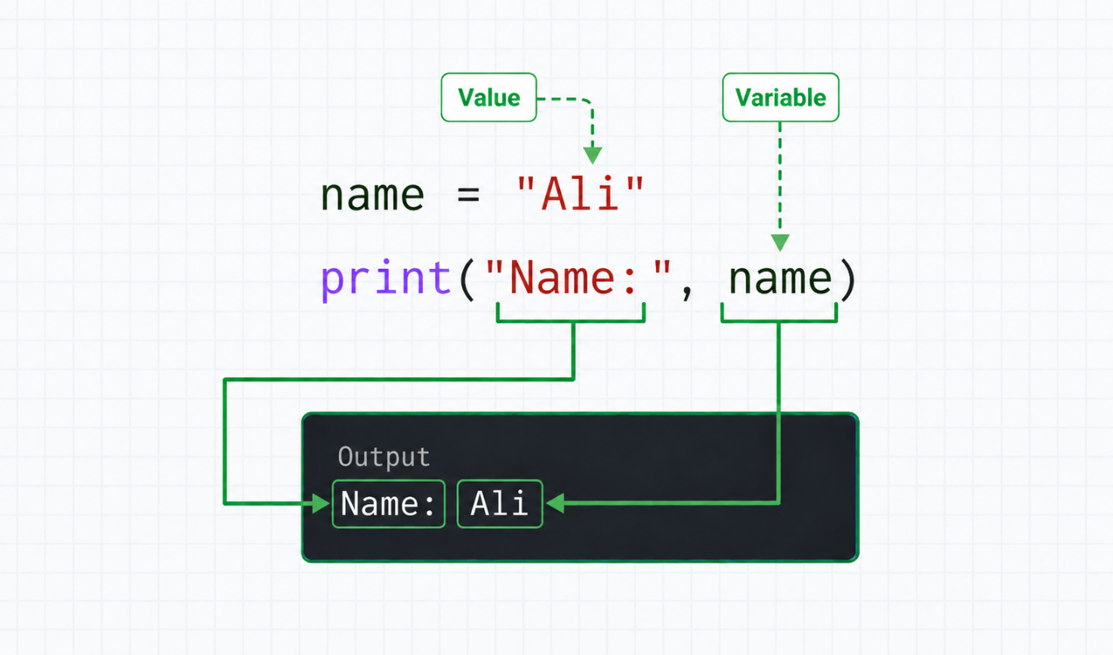
Figure: Print Strings and Variables in the Same Line

PAGE 5.4
Quiz: What is the output of the following Python code?
favorite_sport = "Cricket"
print("Favorite sport:", favorite_sport)

Tap an option below to answer:
A : Favorite sport: Cricket

B : Favorite sport: favorite_sport

C : "Favorite sport:" Cricket

D : Cricket Favorite sport:

PAGE 5.5
PROBLEM
Print a String and a Number
Write a program to print a string and a number using a single print() function.
- Create a variable named score and assign it the value 95.
- Create another variable named message and assign it the string "My score is:".
- Use a single print() function to display the message and score variables together.
Example
Expected Output
My score is: 95

SOLUTION
Would you like to view the full solution? Click below to see it.
View full solution
sensAI
Here is the solution for the given problem description.
# Create the score variable
score = 95

# Create the message variable
message = "My score is:"

# Print message and score variables
print(message, score)

Want to understand how the solution code works? Let me explain.
Explain this code
Let's understand how the code works:
First, the variable score stores the number 95.
Next, the variable message stores the string "My score is:".
Finally, print(message, score) displays both values together. The comma separates the values, and Python automatically adds a space between them.

PAGE 5.6
Print Newline (Enter Key)
It's possible to use a single print() function to display output in multiple lines.
To do this, we use the newline character \n in the position where we want to break the line:
print("Welcome to Go Coder \n The Inspiring Man")
Run Code >>

Output
Welcome to Go Coder
The Inspiring Man

Every use of \n adds a newline. So, if we use another \n, it will add a space between the separated lines.
print("Welcome to Go Coder \n\n The Inspiring Man")

Output
Welcome to Go Coder
The Inspiring Man

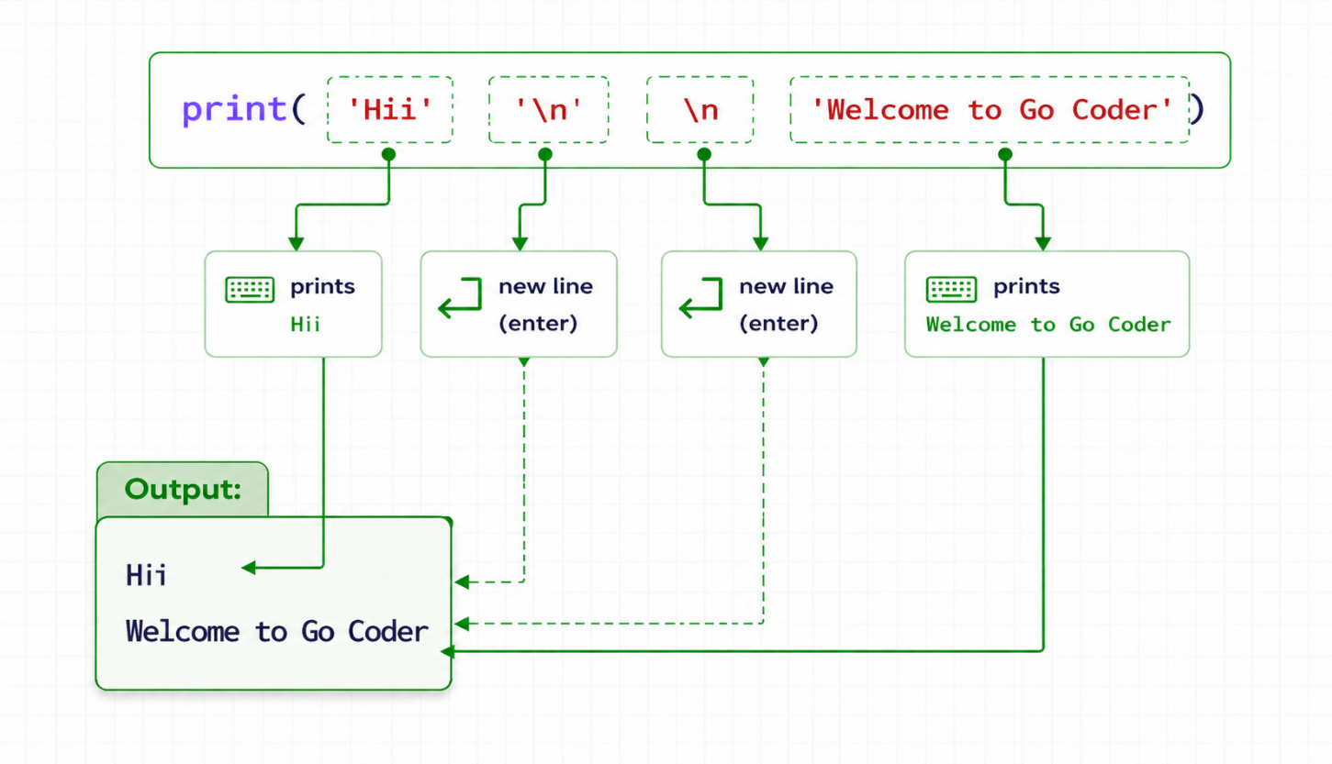
Figure: Print Newline Character

PAGE 5.7
Quiz: What's the output of the following Python code?
print("Dubai\nis beautiful")

Tap an option below to answer:
A : Dubai\nis beautiful

B : Dubai is beautiful

C : Dubai
is beautiful

D : Dubaiis beautiful

PAGE 5.8
PROBLEM
Newline
Write a program to display Hey and How are you in two different lines using a single print() function.
Example
Expected Output
Hii
Welcome to Go Coder

Tip : Use \n between Hii and Welcome to Go Coder. Also, make sure you don't use any spaces after Hii, as it will cause the exercise to fail.

SOLUTION
Would you like to view the full solution? Click below to see it.
View full solution
sensAI
Here is the solution for the given problem description.
print("Hii\nWelcome to Go Coder")

Want to understand how the solution code works? Let me explain.
Explain this code
Prints a friendly message with a neat line break! Here's how it works:

This code uses the print() function to display text on the screen.

The special character \n creates a new line, so "Welcome to Go Coder" appears below "Hii".

It's a simple way to display text on separate lines using a single print() statement.

Ready to explore more ways to format your output?

PAGE 5.9
Python f-strings
Python provides another way to format and display strings called f-strings. They make it easier to include multiple values and variables in your output.
To create an f-string, simply place the letter f before the opening quotation mark. For example:
print(f"Hii")

RunCode >>

This code is equivalent to:
print("Hii")

Run Code >>

The real benefit of f-strings becomes clear when you use them with variables. Let's explore that next.

PAGE 5.10
Print Variables Using f-strings
You can include variables in an f-string by placing their names inside curly braces {}.
For example:
name = "Ali"
location = "London"
print(f"My name is {name} and I live in {location}.")
Run Code >>

Output
My name is Ali and I live in London.

Here's how this program works:
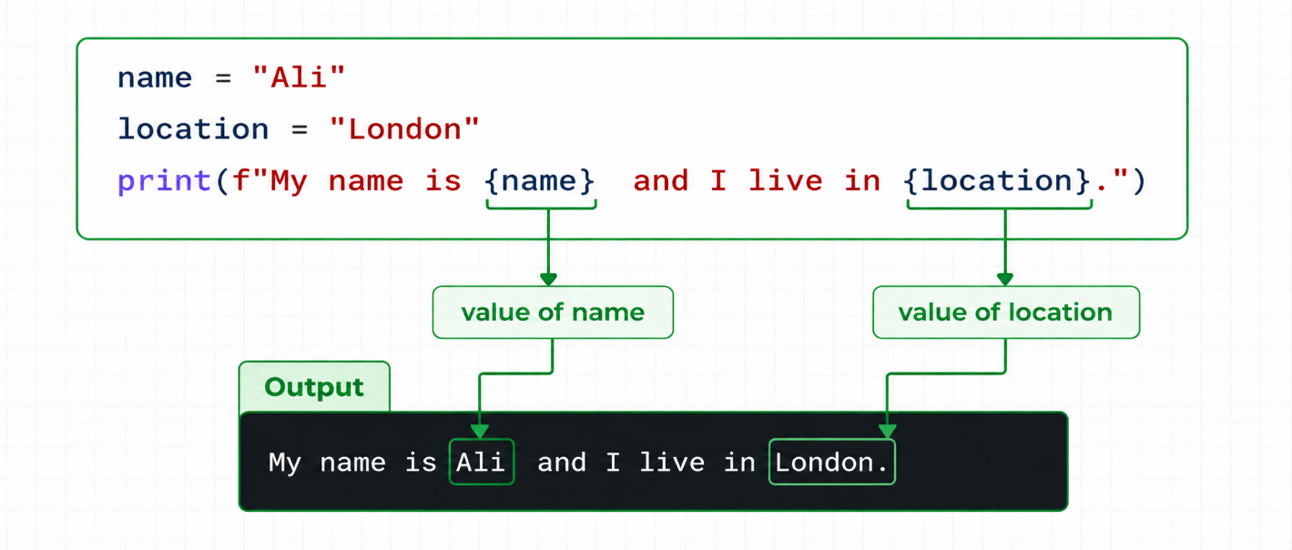
Figure: Working of fstrings

F-strings also allow you to control the spaces and formatting in your output. For example,
name = "Ali"
id = 10
print(f"# {id}->{name} #")
Run Code >>

Output
# 10->Ali #

This makes f-strings a simple and convenient way to combine variables and text in a formatted output.

PAGE 5.11
Quiz: What's the output of the following Python code?
name = "Ali"
age = 25
print(f"{name} is age years old.")

Tap an option below to answer:
A : Ali is 25 years old.

B : name is age years.

C : {name} is age years old.

D : Ali is age years old.

PAGE 5.12
PROBLEM
Python f-strings
Write a program to display text in the required format using an f-string.
- Create a variable movie with the value "Inception".
- Create a variable director with the value "Christopher Nolan".
- Use an f-string to display the output in the format shown below.
Example
Expected Output

Inception directed by Christopher Nolan.

SOLUTION
Would you like to view the full solution? Click below to see it.
View full solution
sensAI
Here is the solution for the given problem description.
movie = "Inception"

director = "Christopher Nolan"

print(f"{movie} directed by {director}.")

Want to understand how the solution code works? Let me explain.
Explain this code
Let's see how it works:

First, the variable movie stores the text "Inception", while director stores "Christopher Nolan".
The print() function uses an f-string to combine these variables with the surrounding text. The variable names inside curly braces {} are replaced with their stored values.
As a result, the program displays:
Inception directed by Christopher Nolan.
F-strings provide a simple way to create formatted text by combining strings and variables.

PAGE 5.13
Common Errors (I)
Before continuing to the next lesson, let's look at some common mistakes that beginners often make.
1. Spelling Mistakes
Using an incorrect variable name or misspelling a word can cause an error. For example:
monthly_income = 80000

# Error due to a spelling mistake
print(monthly_incom)
Run Code >>

Output
File "<string>", line 4, in <module>
NameError: name 'monthly_incom' is not defined. Did you mean: 'monthly_income'?

In many cases, reading the error message carefully can help you identify and fix the problem.
Here, the message shows that monthly_incom has not been defined.
Also, Python is case-sensitive. This means monthly_income and Monthly_income are considered different names.
The same applies to print()—writing Print() or changing its capitalization will also cause an error.

2. Adding Unnecessary Spaces at the Beginning
In Python, spaces at the beginning of a line can have a special purpose. Adding them where they are not needed may result in an error. For example:
print("Welcome Buddy") #Error

Run Code >>

If you run this program, Python will produce an error because there are unnecessary spaces before print().

PAGE 5.14
Common Errors (II)
3. Errors with Quotation Marks
Another common mistake is forgetting to close a string with quotation marks. For example:
print("Welcome Buddy) # Error

Run Code >>

Here, Python cannot understand where the string ends.
"Welcome is not a complete string because the closing quotation mark is missing. This causes a syntax error.
4. Forgetting Commas in the print() Function
age = 25
print("Age:" age) # Error
Run Code >>

Here, Python cannot correctly interpret "Age:" age, so the code results in an error.

5. Forgetting to use f in a f-string
age = 25
print("Age = {age}") # Output: Age = {age}
Run Code >>

If you forget to add f before the quotation marks, Python treats the text as a regular string.
As a result, {age} is displayed as plain text instead of being replaced with the value of the age variable.
You can improve your Python skills by practicing regularly and staying mindful of common mistakes. To learn more about printing in Python, check out the Printing Basics in Python article.

PAGE 6.1
Introduction to Operators
So far, we have mainly focused on displaying values and variables using print().
However, while solving problems, you will often need to perform calculations using values and variables. To do this, Python uses operators.
An operator is a special symbol that performs an operation on values or variables. For example:
total = 8 + 7
print(total) # Output: 15
Run Code >>

In this program, the + symbol is an operator used to add two values.
Next, let's explore different types of operators and learn how to use them.

PAGE 6.2
Arithmetic Operators
Let's explore the operators covered in this lesson.
As the name suggests, arithmetic operators are used to perform basic mathematical calculations. They are summarized below:
Operator | Syntax | Meaning
+ | x + y | Addition
- | x - y | Subtraction
* | x * y | Multiplication
/ | x / y | Division
% | x % y | Remainder
// | x // y | Quotient
** | x ** y | Exponentiation

Let's start with the + operator.

PAGE 6.3
+ Operator
As we learned in the previous example, the + operator is used to add operands, such as values and variables.
x = 15
y = 20
# Use + to perform addition
total = x + y + 35
print(total) # Output: 70
Run Code >>

In this program, total = x + y + 30 calculates the sum of x, y, and 30. The result is then stored in the total variable.
When print(total) runs, it displays:
60

PAGE 6.4
Perform an Operation and Print
You can also perform addition directly inside print() without creating an extra variable.
For example:
x = 15.5
y = 8
print(x + y) # Output: 23.5
Run Code >>

Here, print(x + y) first adds the values of x and y. Then, the result is displayed directly on the screen.

PAGE 6.5
Quiz: What is the output of the following Python code?
x = -2
y = 10
print(y + x)

Tap an option below to answer:
A : 12

B : 10-2

C : 8

D : -8

PAGE 6.6
- Operator
The - operator is used to subtract the value on the right from the value on the left.
x = 12
y = 7
result = x - y
print(result) # Output: 5
Run Code >>

Here, result = x - y subtracts y from x. The calculated result is then stored in the result variable.

PAGE 6.7
PROBLEM
Calculate Profit
Write a program to calculate the profit made from selling a book.
- The cost price of a book is 50 dollars.
- The selling price of the book is 30 dollars.
- Calculate the profit amount and print it.
Tip : The profit amount is calculated by subtracting the cost price from the selling price.
Example
Expected Output
20

SOLUTION
Would you like to view the full solution? Click below to see it.
View full solution
sensAI
Here is the solution for the given problem description.
# Create the cost_price variable
cost_price = 50
# create the selling_price variable
selling_price = 30
# Computer the profit
profit = selling_price - cost_price
print(profit)

Want to understand how the solution code works? Let me explain.
Explain this code
No profit without a sale! Here's how it works:
This little piece of code is tackling the age-old business problem of calculating profit. Sounds fancy, right? But it's actually pretty straightforward.
First, we set cost_price to 50, representing what it costs to create or purchase a product. Then, we set selling_price to 30, which is how much we sell it for.
The fun happens in the line where profit is calculated by subtracting cost_price from selling_price. This simple math tells us we make a tidy profit of 20.
Finally, we display the profit with a quick print function.
Ever thought coders and entrepreneurs share the thrill of a great profit margin? Ready to dive into more?

PAGE 6.8
* Operator
The * operator is used to multiply two values or variables.
number1 = 6
number2 = 8
# Compute the product of number1 and number2
product = number1 * number2
print(product)
Run Code >>

Output
48

Let's take one more example.
number = 7.5
# Calculate the product of number and 4
product = number * 4
print(product)
Run Code >>

Output
30.0

PAGE 6.9
Quiz: What is the output of the following Python code?
a = 15
b = 4.0
print(a * b)
Run Code >>

Tap an option below to answer:
A : 19.0

B : 60

C : 60.0

D : Error

PAGE 6.10
/ Operator
The / operator is used to divide one value by another. For example:
number = 30
result = number / 4
print(result)
Run Code >>

Output
7.5

Let's take another example.
number = 30
result = number / 5
print(result)
Run Code >>

Output
6.0

Note: The / operator always returns a floating-point value. For example, 30 / 5 gives 6.0, not 6.

PAGE 6.11
Quiz: What is the output of the following Python code?
result = 12 / 3 * 5
print(result)
Tap an option below to answer:
A : Error

B : 20.0

C : 0.8

D : 60

PAGE 6.12
// and % Operator
The / operator performs division. However, if you need to find the quotient instead, use the // operator.
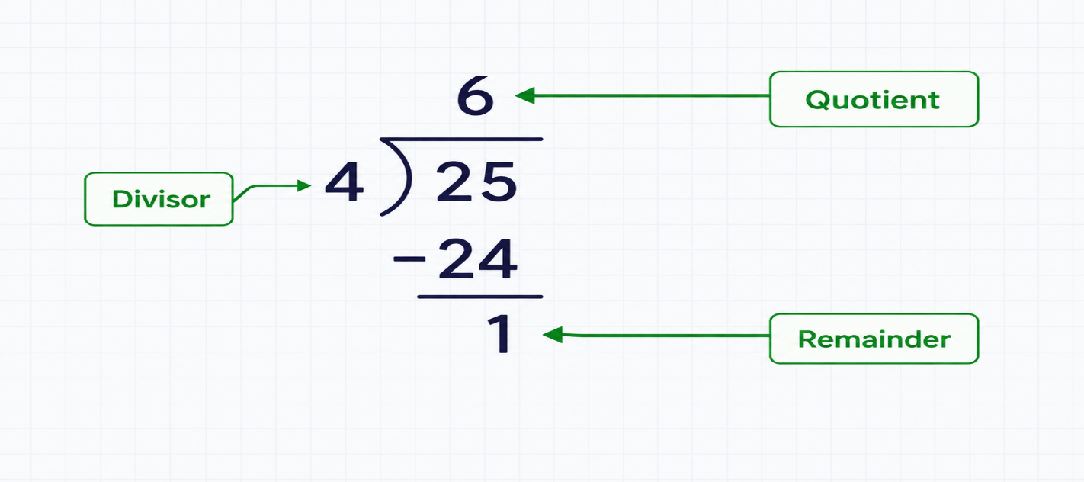
Figure: Basic Division Operation
Let's take an example.
divisor = 4
dividend = 25

# Compute quotient
quotient = dividend // divisor

print(quotient) # Output: 6

Run Code >>

% Operator
The % operator computes the remainder when one number is divided by another.
divisor = 4
dividend = 25

# compute remainder
remainder = dividend % divisor

print(remainder) # Output: 1
Run Code >>

PAGE 6.13
PROBLEM
Divide Candies Among Children
Write a program to divide candies equally among children.
Imagine you have to divide 17 candies among 4 children equally. Your task is to find out:
- How many candies each child will get when divided equally?
- How many candies will be left over?
To solve this problem:
- Create a variable named candy_number and assign it the value 17.
- Create another variable named child_number and assign it the value 4.
- Calculate the number of candies each child will receive and print the result.
- Calculate the number of remaining candies and print the remainder.
Example
Expected Output
Candies for each child: 4
Remaining candies: 1

Tip : Make sure your output matches the expected output exactly.

SOLUTION
Would you like to view the full solution? Click below to see it.
View full solution
sensAI
Here is the solution for the given problem description.
candy_number = 17
child_number = 4

quotient = candy_number // child_number
print(f"Candies for each child: {quotient}")

remainder = candy_number % child_number
print(f"Remaining candies: {remainder}")

Want to understand how the solution code works? Let me explain.
Explain this code
Let's see how it works:
The program divides 17 candies equally among 4 children. The // operator performs integer division, so each child receives 4 candies.
Next, the % operator finds the remainder after division. Since 17 cannot be divided equally by 4, 1 candy is left over.
Finally, f-strings are used to display both results in the required format.
This example demonstrates how // and % can be used together to find the quotient and remainder.

PAGE 6.14
** Operator
The ** operator computes the exponential (power) of a number.
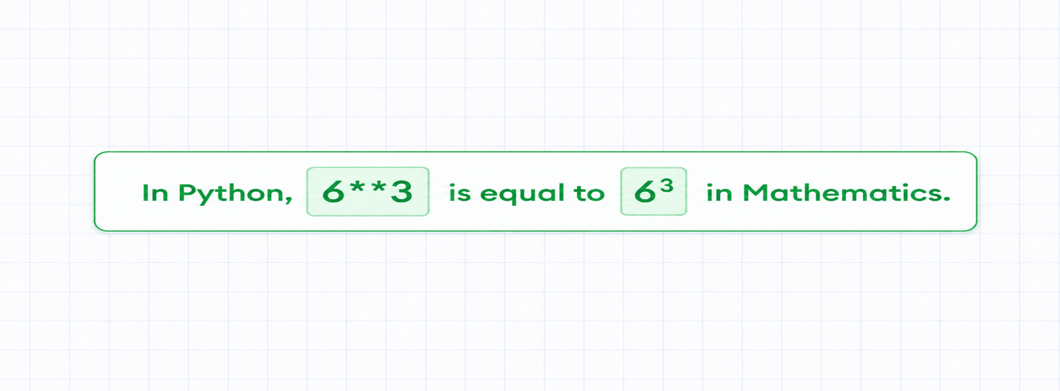
Figure: Power of a Number
Let's take an example.
base = 6
power = 3

result = base ** power
print(result)
Run Code >>

Output
216

Let's take another example.
base = 3.5
power = 3

result = base ** power
print(result)
Run Code >>

Output
42.875

PAGE 6.15
Quiz: What is the output of the following code?
result = 4 ** 3
print(result)

Tap an option below to answer:
A : 62

B : 64

C : 16

D : 63

PAGE 6.16
PROBLEM
Volume of Cube
Write a program to find the volume of a cube.
- Create a variable named length and assign it the value 9.
- Calculate the volume of the cube using its length.
- Print the volume.
Tip : The volume of a cube is calculated as:
volume = $length^{3}$
Example
Expected Output
729

SOLUTION
Would you like to view the full solution? Click below to see it.
View full solution
sensAI
Here is the solution for the given problem description.
length = 9

# Calculate the volume
volume = length ** 3

# Print the result
print(volume)

Want to understand how the solution code works? Let me explain.
Explain this code
Got a cube to conquer? Here's how it works:
This code snippet is a tiny geometric powerhouse aimed at calculating the volume of a cube. The line length = 9 sets your cube's side length as 9 units.
Bam! We raise this length to the power of 3, using the line volume = length ** 3. Voila, you now have the cube's volume stored neatly in the variable "volume".
Finally, the code unleashes its magic with print(volume). Prepare to bask in the brilliance of the number "729", representing your cube's volume.
Isn't coding with precision cubes such a delight? So, what's your next coding adventure?

PAGE 6.17
Using Parentheses in Arithmetic Operations
Can you predict the output of the following program?
result = 3 * 4 - 8 / 2
print(result)
Run Code >>

Sometimes, it can be difficult to understand which operation Python performs first.
To make the calculation clearer, we can use parentheses:
result = (3 * 4) - (8 / 2)
print(result)
Run Code >>

Now, our code is much easier to understand. The operations are performed in a certain order during calculations. Refer to this article to learn more.

PAGE 6.18
PROBLEM
Calculate Shopping Discount
Write a Python program to calculate the final price after applying a discount.
You want to buy an item that costs $2000.
The store offers a 15% discount. To solve this problem:
- Create a variable named price and assign 2000 to it.
- Create another variable named discount_percent and assign 15 to it.
- Calculate the discount using the formula (discount_percent / 100) * price and store it in the discount variable.
- Subtract the discount from the original price to calculate the final amount.
- Print the final amount.

Example
Expected Output
1700.0

SOLUTION
Would you like to view the full solution? Click below to see it.
View full solution
sensAI
Here is the solution for the given problem description.
price = 2000

discount_percent = 15

discount = (discount_percent / 100) * price

final_price = price - discount

print(final_price)

Want to understand how the solution code works? Let me explain.
Explain this code
Let's break it down! Here's how it works:
The code starts by storing the original price and the discount percentage in variables.
Next, it calculates the discount amount by converting the percentage into a fraction and multiplying it by the original price.
Then, the discount is subtracted from the original price to find the final amount.
Finally, print(final_price) displays the amount you need to pay.

PAGE 6.19
Arithmetic Assignment Operators
Consider this program:
total = 100
total = total + 5

print(total) # Output: 105
Run Code >>

In this program, we have added the value of the variable total to 5, and assigned the result back to the total variable.
In such case, we can use the arithmetic assignment operators += to simplify code:
total = 105

# Equivalent to: total = total + 5
total += 5

print(total)
Run Code >>

Consider reading Python Assignment Operator to explore more examples of arithmetic assignment operators.

PAGE 6.20
Review : Operators
We've now completed our lesson on arithmetic operators.
Before moving on, let's quickly review the arithmetic operators you have learned in Python:
Operator | Syntax | Meaning
+ | x + y | Addition
- | x - y | Subtraction
* | x * y | Multiplication
/ | x / y | Division
// | x // y | Quotient
% | x % y | Remainder
** | x ** y | Exponentiation

Ready for the next lesson? You'll now learn how to convert data from one type to another.

PAGE 7.1
Introduction to Data Conversion
So far in this course, you have worked with three common data types:
- Integer — 8, -4, 25, 0
- Float — 3.5, 0.0, -6.25, 12.0
- String — "Hello", "8", "My score is 10"
In real-world programs, data may not always be in the form you need. For example, a number can sometimes be stored as text, such as "7.5".
In these situations, you may need to convert data from one type to another. In this lesson, you will learn how to perform these data conversions.

PAGE 7.2
Convert to Integer
We use the int() function to change data from another type into an integer.
Convert Float to Integer
float_number = 32.0

# Convert float to integer
integer_number = int(float_number)

print(integer_number) # Output: 32
Run Code >>

Here, the int() function changes the floating-point value into its corresponding integer.

Convert String to Integer
string_number = "32"

# Convert string to integer
# integer_number will contain 32
integer_number = int(string_number)

print(integer_number) # Output: 32
Run Code >>

Here, the int() function converts the string to its equivalent integer.
Note: If int() cannot convert a string into a valid integer, Python will produce an error.

Next, let's look at an example.

PAGE 7.3
Error Converting a String to an Integer
We cannot convert all types of strings to integers. Let's take an example.
string_number = "Sara!"

# Convert the string to an integer
integer_number = int(string_number) # Error!

print(integer_number)
Run Code >>

Output
ValueError: invalid literal for int() with base 10: 'Sara!'

Here, Python cannot convert "Sara!" into an integer because the string contains letters instead of a valid number. Therefore, the int() function produces an error.

PAGE 7.4
Convert to Float
We use the float() function to convert data from other types into floating-point numbers.
Convert Integer to Float
integer_number = -25

# Convert integer to float
float_number = float(integer_number)

print(float_number) # Output: -25.0
Run Code >>

Here, the float() function changes the integer value into its equivalent floating-point number.
Convert String to Float
string_number = "-25.65"

# Convert the string to a float
float_number = float(string_number)

print(float_number) # Output: -25.65
Run Code >>

Here, the float() function converts the string into its corresponding floating-point value.
Note: Just like int(), the float() function will produce an error if the string cannot be converted into a valid floating-point number.

Next, let's look at another example of an invalid conversion.
PAGE 7.5
Error Converting a String to a Float
Just as not every string can be converted to an integer, some strings also cannot be changed into floating-point numbers. Let's look at an example:
string_number = "12a"

# Convert the string to a float
float_number = float(string_number) # Error!

print(float_number)
Run Code >>

Output
ValueError : could not convert string to float: '12a'

Here, Python cannot convert "12a" into a floating-point number because it contains both numbers and letters. Therefore, the float() function produces an error.

PAGE 7.6
PROBLEM
Convert Type
Write a program to convert values from one data type to another.
- Create a variable named a and assign the string value "6" to it.
- Create another variable named b and assign the string value "7" to it.
- Convert the values stored in a and b to integers and multiply them.
- Print the result.
Example
Expected Output
42

SOLUTION
Would you like to view the full solution? Click below to see it.
View full solution
sensAI
Here is the solution for the given problem description.
# Create variables a and b
a = "6"
b = "7"

# Convert the values to integers and multiply them
result = int(a) * int(b)

# Print the result
print(result)

Want to understand how the solution code works? Let me explain.
Explain this code
Let's turn text into numbers! Here's how it works:

The variables a and b store "6" and "7" as strings. Since strings cannot be used directly for this multiplication, the int() function converts both values into integers.
After the conversion, Python multiplies 6 and 7, giving the result 42.
Finally, print(result) displays the answer on the screen.

PAGE 7.7
Convert to String
We use the str() function to convert data from other types into strings. For example,
number = 15.5
number_str = str(15.5)

print(number_str)
Run Code >>

Output
15.5

From the output alone, it may not be obvious that number_str stores a string because printing the original number variable would display the same value.
To confirm the type of data, you can use the type() function, which we have covered in Understanding Python's type() article.

PAGE 7.8
Implicit Type Conversion
There's more to conversion.
Python can also convert data from one type to another automatically in certain situations. For example:
number_integer = 200
number_float = 2.75

# Add an integer and a float
result = number_integer + number_float

print(result)
Run Code >>

Output
202.75

Here, we are adding an integer and a floating-point number.
In this situation, Python automatically converts the integer 200 to its equivalent floating-point value, 200.0, before performing the addition.
That's why the final result is also a floating-point number.

PAGE 7.9
Quiz: What is the output of the following Python code?
var = "30.0"

number = float(var)

result = number - 12

print(result)

Tap an option below to answer:
A : 18.0

B : 18

C : 42.0

D : Error

PAGE 8.1
Introduction to User Input
So far, we have assigned values directly to variables, like this:
name = "Sara"

Now, let's make our programs more interactive.
Instead of giving a variable a value directly, we can ask the user to enter a value and then use that input in our program.
Let's see how to do that next.

PAGE 8.2
Take User Input
You can ask the user to enter a value and store it in a variable using the input() function. For example,
name = input("Enter your name: ")
print("Your name is", name)
Run Code >>

Here, the program prints Enter your name: and then waits for the user to type something.
Suppose the user enters Ali and presses the ENTER key. The text Ali is then stored in the name variable.
When we print the name variable, the entered value is displayed.
Sample Output 1
Enter your name: Sara
Your name is Sara

Sample Output 2
Enter your name: Emily
Enter your name: Ali

Your name is Ali

PAGE 8.3
User Input Without a Prompt
Let's look at another example of taking user input.
full_name = input()
print("Full Name:", full_name)
Run Code >>

Sample Output
Ali
Full Name: Ali khan

Here, the input() function is used without any text inside it.
The line full_name = input() does not display a prompt. Instead, the program waits for the user to enter some input.
Once the user types a value and presses the ENTER key, that value is stored in the full_name variable.

PAGE 8.4
PROBLEM
User Input
Write a program to get user input.
- Get the user's first name and store it in the first_name variable.
- Get the user's last name and store it in the last_name variable.
- Print the variables in the format shown in the Expected Output section.
Example
Test Input
Sara
Micheal

Expected Output
First Name: Sara
Last Name: Micheal

Note: This exercise checks the output based on the input provided. To ensure accuracy, multiple test cases have been added to handle different inputs.

SOLUTION
Would you like to view the full solution? Click below to see it.
View full solution
sensAI
Here is the solution for the given problem description.
# Get the first name from the user
first_name = input()

# Get the last name from the user
last_name = input()

# Print the full name
print(f"First Name: {first_name}")
print(f"Last Name: {last_name}")

Want to understand how the solution code works? Let me explain.
Explain this code
Coding is like magic, but you can control the wand! Here's how it works:

This code prompts users to enter their first and last names. First, it captures the first name using the input() function, then it asks for the last name.

After gathering this information, it prints each part clearly with a label. The use of f-strings ensures the output is neat and easy to read.

It’s a simple yet effective demonstration of user input and output in Python, perfect for beginners.

What will you code next to charm the world with your skills?

PAGE 8.5
Use input() With Numbers
The input() function always receives user input as a string. Even when the user enters a number, Python stores it as text.
Let's look at an example to understand why this matters.
# Program to multiply numbers entered by the user

# Take input from the user
number1 = input("Enter a number: ")
number2 = input("Enter another number: ")

product = number1 * number2
print("Product:", product)
Run Code >>

Sample Output
Enter a number: 5
Enter another number: ERROR!10
Traceback (most recent call last):
File "<string>", line 7, in <module>
TypeError: can't multiply sequence by non-int of type 'str'

This program will give us an error after we enter two numbers. It's because the input() function takes input in the form of a string.
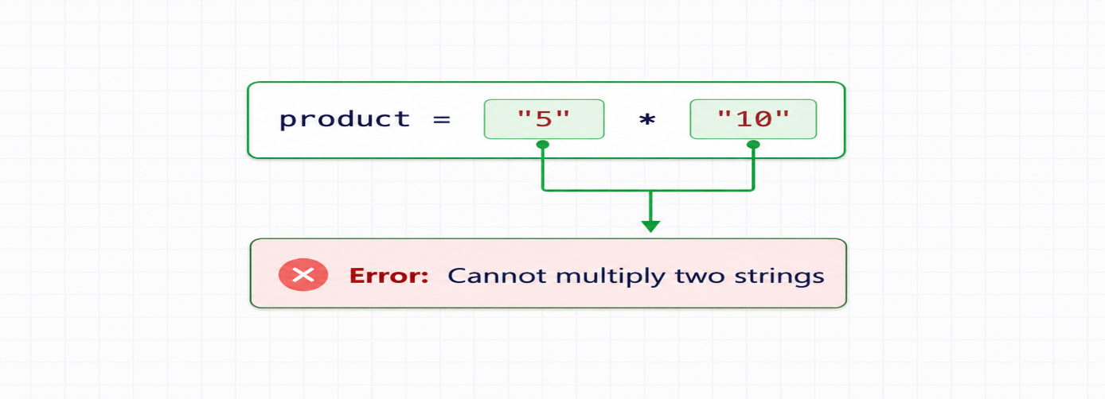
Figure: Cannot Multiply Two Strings
Here :
- "5" is stored in number1 instead of the integer 5.
- "10" is stored in number2 instead of the integer 10.
Therefore, number1 * number2 causes an error because two strings cannot be multiplied together.
So, how do we solve this problem?
We cannot directly take integers and floats as input.
We cannot directly receive integers or floating-point numbers using input(). However, we can convert the entered strings into integers using int() or into floating-point numbers using float().
Let's see how to do that next.

PAGE 8.6
Use input() With Numbers
Let's fix the error from the previous example.
# Program to multiply numbers entered by the user

# Take input from the user
number1 = input("Enter a number: ")
number2 = input("Enter another number: ")

# Convert strings to floating-point numbers
number1 = float(number1)
number2 = float(number2)

product = number1 * number2
print("Product:", product)
Run Code >>

Sample Output
Enter a number: 5
Enter another number: 10
Product: 50.0

In this program, we have added lines to convert the string, "5", stored in number1 to its equivalent floating-point number, 5.0. We have done the same for number2.
# Convert strings to floating-point numbers
number1 = float(number1)
number2 = float(number2)

Now, the product = number1 * number2 statement works as expected.

PAGE 8.7
A General Tip
By the way, We can also write the previous program in a shorter way:
# Program to multiply numbers entered by the user

# Take input from the user
number1 = float(input("Enter a number: "))
number2 = float(input("Enter another number: "))

product = number1 * number2
print("Product:", product)
Run Code >>

Here, the value entered by the user is converted to a float before it is assigned to the variable.
Basically, this code
number1 = float(input("Enter a number: "))

is equivalent to
number1 = input("Enter a number: ")
number1 = float(number1)

This method lets you convert user input directly to an int or float while using fewer lines of code.

PAGE 8.8
Quiz: Given the Python code snippet below, which of the following values can be stored in the variable number after user input?
number = input("Enter a number: ")

Tap an option below to answer:
A : 20 (integer)

B : "20" (string)

C : 20.0 (floating-point number)

D : 18 (integer)

PAGE 8.9
PROBLEM
User Input
Write a program to perform arithmetic operations using user input.
- Get two numeric values from the user, convert them to float, and store them in the variables number1 and number2.
- Add number1 and number2, and store the result in the result variable.
- Print the square of the result variable.
Example
Test Input
7.5
3.5

Expected Output
121.0

Reason: The sum of 7.5 and 3.5 is 11.0. And, the square of 11.0 is 121.0.

SOLUTION
Would you like to view the full solution? Click below to see it.
View full solution
sensAI
Here is the solution for the given problem description.
# Get two floating-point numbers from the user
number1 = float(input("Enter a number: "))
number2 = float(input("Enter another number: "))

# Add the numbers
result = number1 + number2

# Print the square of the result
print(result ** 2)

Want to understand how the solution code works? Let me explain.
Explain this code
Ready to unleash your inner mathematician? Here's how it works:
The code prompts the user for two floating-point numbers.
It then adds the numbers together and stores the result.
Finally, it prints the square of that result, showing you just how much bigger that number can get!
This code is a great way to practice user input, arithmetic, and working with powers.
Keep playing with numbers! What other interesting things can you do with code today?

PAGE 9.1
Introduction Examples
Take a moment to appreciate how much you have learned so far—you're almost at the end of the first chapter!
In this lesson, you will create some interesting programs using the concepts you've learned.
- Convert Kilometers to Miles
- Practice: Convert Celsius to Fahrenheit
- Find the Square Root of a Number
- Practice: Find the Area of a Triangle
- Swap Two Variables

PAGE 9.2
Convert Kilometers to Miles
We can change a distance from kilometers into miles using the following conversion:
1 kilometer = 0.621 miles
Example
# Program to convert a distance from kilometers to miles
# The user will enter the distance

# Get the distance in kilometers
km = float(input("Enter distance in km: "))

# Conversion value
ratio = 0.621

# Calculate the distance in miles
miles = km * ratio

print(f"Distance in miles: {miles}")
Run Code >>

Output
Enter distance in km: 10
Distance in miles: 6.21

Here's how this program works.
In line 6: km = float(input("Enter distance in km: "))
We are taking input from the user using the expression input("Enter distance in km: ").
Before it's assigned to the variable, we have converted it to a floating-point number using the float() function. It's because we want the distance to be a number, not a string.
In line 12: miles = km * ratio
The distance in kilometers is multiplied by 0.621 to calculate the equivalent distance in miles.
PAGE 9.3
PROBLEM
Fahrenheit to Celsius
Write a program to convert temperature from Fahrenheit to Celsius.
Formula:
celsius = (fahrenheit - 32) / 1.8

- Get the temperature in Fahrenheit from the user and store it in a variable.
- Convert the temperature to Celsius using the formula above.
- Print the result.

Example
Test Input
86

Expected Output
30.0

SOLUTION
Would you like to view the full solution? Click below to see it.
View full solution
sensAI
Here is the solution for the given problem description.
# Get temperature in degrees Fahrenheit from the user
fahrenheit = float(input())

# Convert it to degrees Celsius using the formula
celsius = (fahrenheit - 32) / 1.8

# Print the temperature in Celsius
print(celsius)

Want to understand how the solution code works? Let me explain.
Explain this code
Let's cool things down! Here's how it works:
The program first takes a temperature in Fahrenheit from the user and converts the input into a floating-point number.
Next, it uses the formula (fahrenheit - 32) / 1.8 to calculate the equivalent temperature in Celsius.
Finally, the Celsius value is printed on the screen.
This program is a simple way to practice user input, arithmetic operations, and temperature conversion in Python.

PAGE 9.4
Find the Square Root
The square root of a number is a value that, when multiplied by itself, gives the original number.
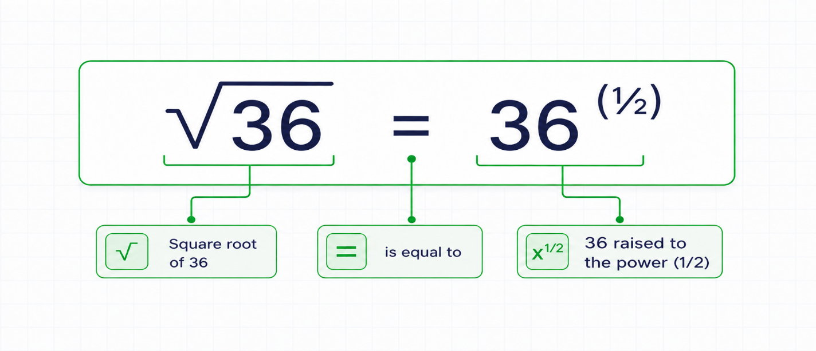
Figure: Find Square Root
We can use the ** operator, also known as the exponent operator, to calculate a square root.
Example
number = 36

square_root = number ** (1/2)
print(f"Square root of {number} is {square_root}")
Run Code >>

Output
Square root of 36 is 6.0

PAGE 9.5
PROBLEM
Calculate the Area of a Triangle
Write a program to calculate the area of a triangle.
Suppose a, b, and c represent the three sides of a triangle. The area can be calculated using:
$$\text{semi-perimeter }(s)=\frac{a+b+c}{2}$$
$$\text{area}=\sqrt{s(s-a)*(s-b)*(s-c)}$$
- Get three numeric values from the user and store them in a, b, and c.
- Calculate the semi-perimeter s.
- Use the formula above to calculate the area of the triangle.
- Print the area.
Tip : To calculate the square root of a number, such as 36, you can use 36 ** (1/2).
Example
Test Input
4
6
8

Expected Output
11.618

SOLUTION
Would you like to view the full solution? Click below to see it.
View full solution
sensAI
Here is the solution for the given problem description.
# Get the three sides of the triangle
a = int(input("Enter the first side: "))
b = int(input("Enter the second side: "))
c = int(input("Enter the third side: "))

# Calculate the semi-perimeter
s = (a + b + c) / 2

# Calculate and print the area
area = (s * (s - a) * (s - b) * (s - c)) ** (1/2)
print(area)

Want to understand how the solution code works? Let me explain.
Explain this code
Ready to become a triangle expert? Here's how it works:
This code helps you calculate the area of a triangle using the lengths of its three sides.

First, it prompts you to enter the lengths of the sides, then calculates the semiperimeter, which is half the sum of those lengths.

Using Heron's formula, it computes the area based on the semiperimeter and the side lengths. Finally, it prints the area for you.

What a neat way to bring geometry into coding! Keep practicing, and soon you'll be solving even more complex problems. What coding adventure will you tackle next?

PAGE 9.6
Swap Two Variables
Suppose we have two variables like this :
phone1 = "iPhone"
phone2 = "Lenovo vibe"

After swapping their values, we want them to become:
phone1 = "Lenovo vibe"
phone2 = "iPhone"

Before looking at the correct way to swap them, let's try an approach that does not work:
phone1 = "iPhone"
phone2 = "Lenovo vibe"

phone1 = phone2 # Assign phone2's value to phone1
phone2 = phone1 # Assign phone1's value to phone2

print(f"phone1: {phone1}\nphone2: {phone2}")
Run Code >>

Output
phone1: Lenovo vibe
phone2: Lenovo vibe

Can you understand why this approach fails?
At the beginning, phone1 stores "iPhone" and phone2 stores "Lenovo vibe".
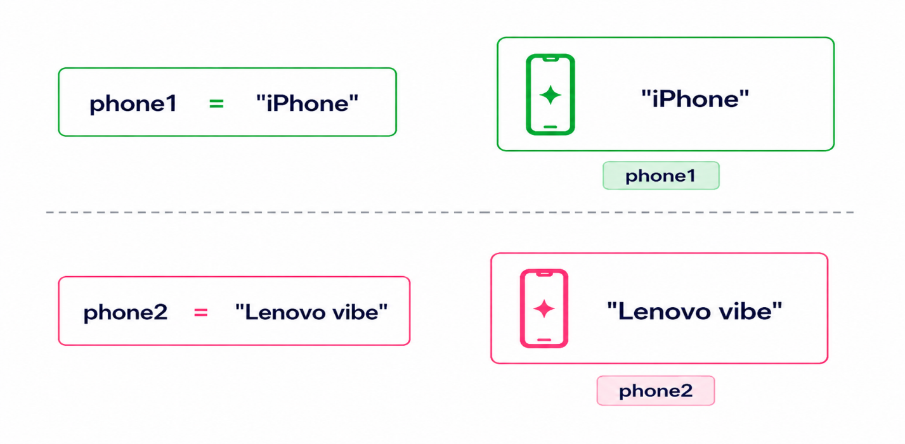
Figure: Assign Values to phone1 and phone2

Step1 : Assign phone2 to phone1.
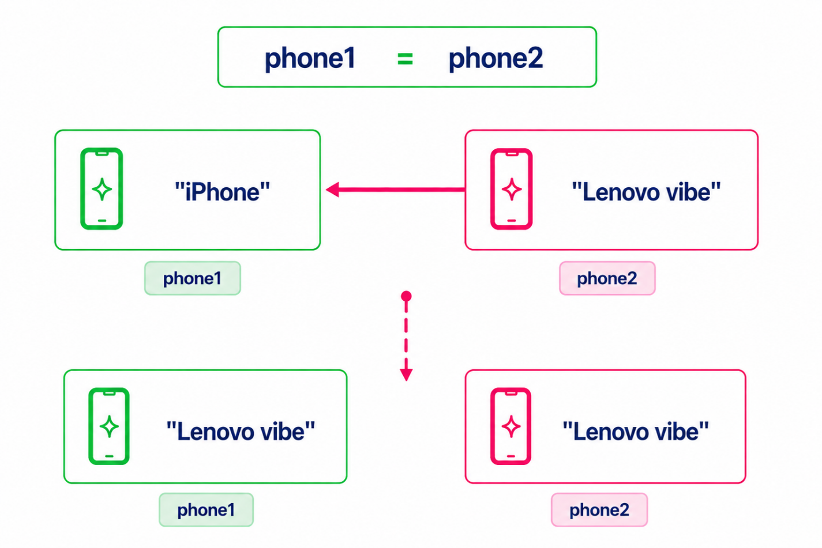
Figure: Assign Value of phone2 to phone1
When this happens, the value "Lenovo vibe" from phone2 replaces the value stored in phone1. Now, both variables contain "Lenovo vibe".
The original value "iPhone" stored in phone1 is overwritten and lost.

Step 2: Assign phone1 to phone2.
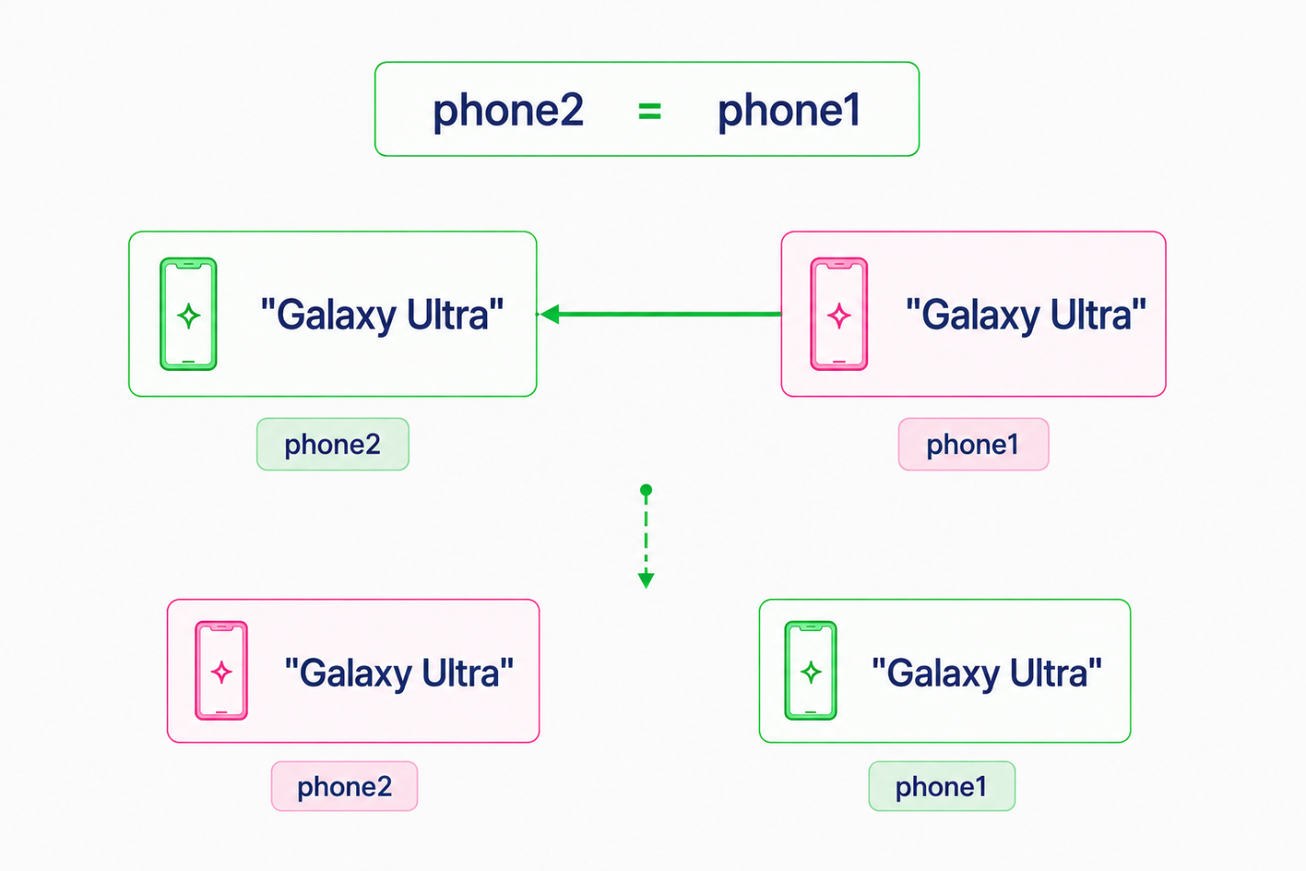
Figure: Assign Value of phone1 to phone2
At this stage, both phone1 and phone2 already contain "Lenovo vibe". Therefore, assigning phone1 to phone2 does not change the value.
This is why both variables end up with "Lenovo vibe". To swap the values correctly, we need to use a different method, which we'll learn next.

PAGE 9.7
Swap Two Variables
To solve the previous problem, you need to store the value of phone1 temporarily in another variable. This prevents the original value of phone1 from being lost during the swap.
phone1 = "iPhone"

phone2 = "Lenovo vibe"

# Store the value of phone1 in another variable
temp_phone = phone1

# Assign phone2 to phone1
phone1 = phone2

# Assign temp_phone (old value of phone1) to phone2
phone2 = temp_phone

print(f"phone1: {phone1}\nphone2: {phone2}")
Run Code >>

Output
phone1: Lenovo vibe
phone2: iPhone

Congratulations
Congratulations🏆!
You have completed the foundational concepts of Python. These are the building blocks of Python programming and will help you approach upcoming topics with confidence.
Let's recap what you learned so far.

REVIEW (1)
Data Types
We started by learning different types of data:
- String: "Welcome to Go Coder", '123a'
- Floating-point Numbers: 14.3, 152.0
- Integers: 231, 142
Variables
To store and use these data later in the program, you can store them in variables.
x = 4
y = x

print(f"y = x = {x}")
Run code >>

Operators
In programming, you often need to perform calculations on values and variables, not just print them. To handle mathematical calculations, we use operators.
x = 7
y = 3

remainder = x % y
power = x ** y

print(f"Remainder: {remainder}")
print(f"Power: {power}")
Run code >>

More on what you learned on the next page.

REVIEW (2)
Take input
You can collect information from the user during program execution with the input() function. The entered value can then be stored in a variable and used in the program.
first_name = input("Enter your first name: ")

last_name = input("Enter your last name: ")

print(f"Hey {first_name} {last_name}!")
Run Code >>

Data conversion
The data you work with may not always be in the format you need. In such cases, you can convert the data from one type to another.
# Convert user input to floating-point numbers
price = float(input("Enter the price: "))
quantity = float(input("Enter the quantity: "))

total = price * quantity
average = total / 2

print(f"Total: {total}")
print(f"Half of total: {average}")
Run Code >>

With these basic concepts covered, you're now ready to move on to the next lesson.

Moving Forward
Feeling confident about what you've learned in this chapter? Great! Click the "Next Lesson" button to move on to the next chapter: Control Flow and Loops. In this chapter, you'll learn about the logic that helps programs make decisions and repeat tasks.
Alternatively, you can take the Practice: Python Basics course to strengthen your understanding before continuing to the next chapter.
Practice: Python Basics
This companion course includes extra practice exercises to help you build confidence and improve your Python skills.
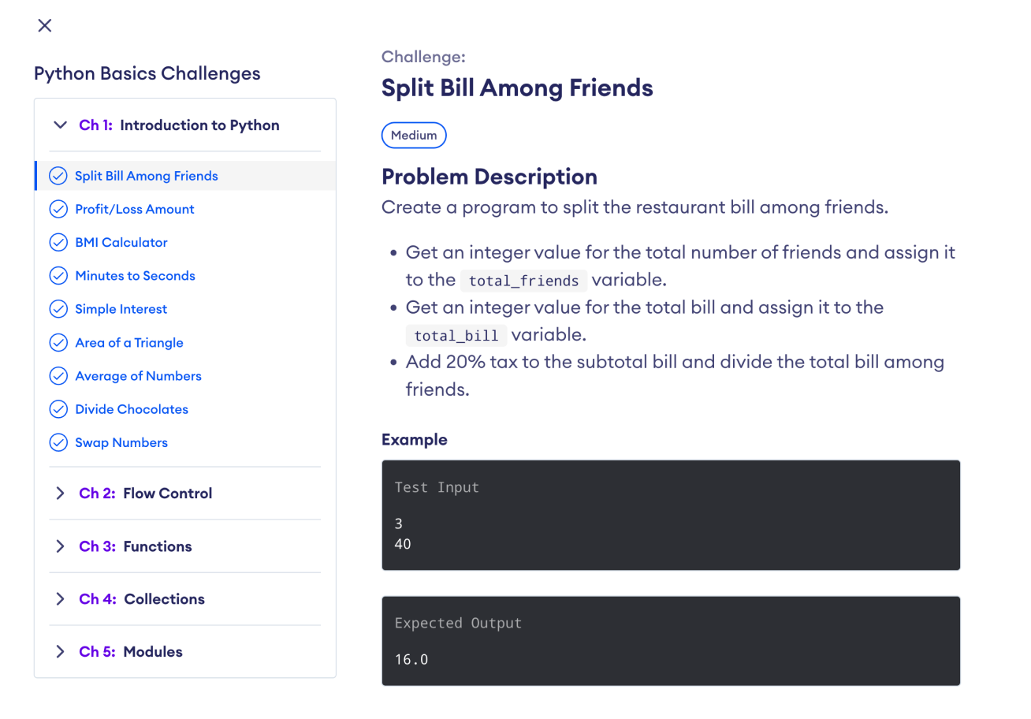
Figure: Practice: Python Introduction
Each chapter of the Practice: Python Basics course corresponds with a chapter in this course, allowing you to apply what you've learned.

FINISH

